**2. Experimental methodology**

2.1 Substrates

Three kinds of superhydrophobic substrate manufactured by silicon wafer using standard photolithography process and deep reactive ion etching are prepared. All the substrates are composed of cylindrical micropillar arrays and the geometry information of the substrates are listed in Table 1. All the substrates were conformally coated with silane (Trichloro (1H,1H,2H,2H-per fluorooctyl)-silane, Sigma-Aldrich) using standard chemical vapor deposition (CVD) process [1]. Then the substrates were placed on a 90°C hot plate for 60 min backing. Water droplet exhibits a contact angle about 155° on all the substrates. To mitigate the sample edges effect on the droplet evaporation process, samples were cut into square pieces with 2 cm length of side and water droplets were deposited at the center of the substrates.

Table 1 Micropillar diameter, periodicity and height of different sample substrates

|  |  |  |  |
| --- | --- | --- | --- |
| Substrate | Micropillar diameter D (μm) | Micropillar periodicity P (μm) | Micropillar height H (μm) |
| Sample 1 | 20 | 40 | 40 |
| Sample 2 | 20 | 50 | 40 |
| Sample 3 | 20 | 60 | 40 |

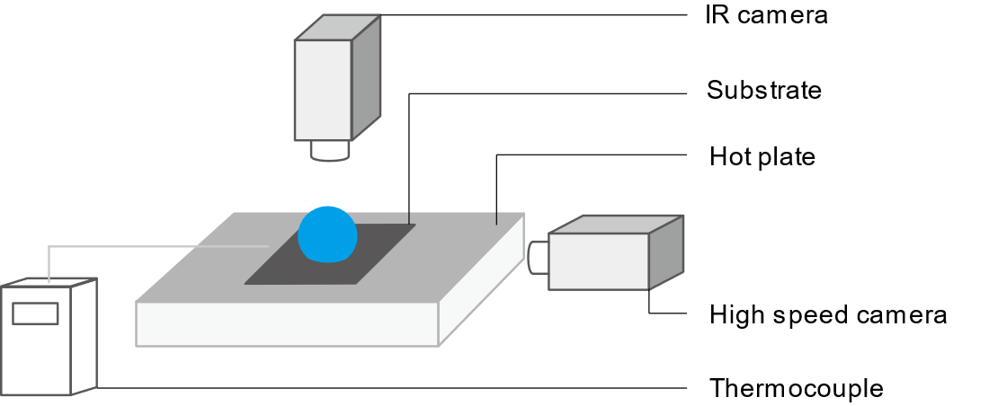

Figure 1. Schematic diagram of the experimental setup including cameras, substrate, hot plate and thermocouple.

2.2 Experimental setup

Fig. 1 shows the schematic diagram of the experimental setup. In this study, deionized (DI) water (Type 1, >18 MΩ cm resistivity) is used as the liquid for the droplet evaporation. 4 μL DI water droplet is deposited on the center of the heated superhydrophobic micro-structured substrate for evaporation. The substrate is heated by a hot plate and the surface temperature of the hot plate is controlled from 40 °C to 120 °C. A K-type thermocouple with $±$ 0.5 °C uncertainty is used to test the surface temperature of the hot plate. Two cameras are used to record the evaporation process of the droplet. A calibrated infrared (IR) camera (FILR A5) is fixed on the top of the droplet and normal to the substrate to measure the surface temperature of the droplet. Because of the superhydrophobicity of the substrate, droplet on the substrate contains large contact angle and only the upper half surface of the droplet can be focused by the IR camera. Regardless the effects of droplet flow on the distribution of the droplet surface temperature, the temperature measured by the IR camera is understood as the average temperature of the droplet upper half surface. A high-speed camera integrated with a contact angle measurement system (Theta Lite, OneAttension Corporation) is used to measure the geometry of the droplet through time. The high-speed camera is set parallel to the substrate to get the snapshots of the droplet. We divide the droplet into layer and obtain the local diameter and heigh of each cylindrical layer from the snapshots to calculate the volume of the droplet with the assumption that the droplet is axisymmetric. With the snapshots obtained by the high-speed camera, transient droplet volume, contact angle, contact radius and droplet height are collected. The ambient temperature and relative humidity are $T_{lab}=23±2$ °C and $RH=35 ±5\%$, respectively.

**3.** **Experimental model**

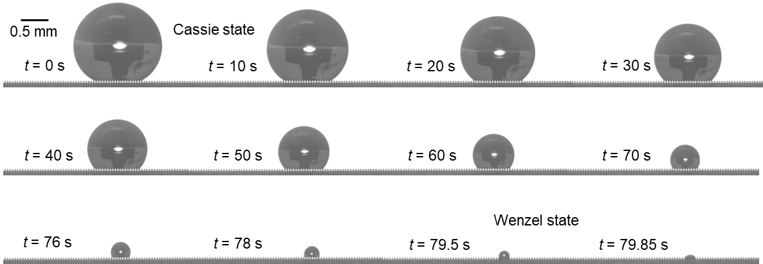

Figure 2. Snapshots of droplet evaporation on superhydrophobic surfaces

3.1 Wetting state

Droplet exhibits different wetting states on the microstructured substrate during the evaporation. The snapshots of droplet evaporation on 100 °C substrate are shown in Fig.2. It is obvious that at the beginning of the evaporation there are air/vapor cavities between the droplet and the substrate, which means the droplet is in Cassie state. At the very end of the evaporation, water liquid fills the cavities between droplet and the substrate and the droplet is in Wenzel state. Though droplet exhibits both Cassie state and Wenzel state during the evaporation, the droplet is in Cassie state during most of the evaporation process. Thus, it is assumed that droplet is in Cassie state in the following analyze of the droplet evaporation.

3.2 Energy balance model

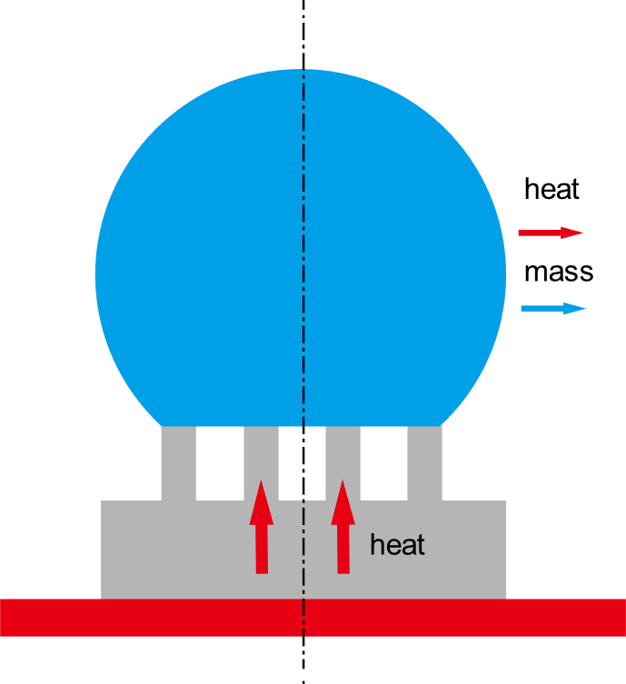

Figure 3. Diagram of droplet evaporation on hot superhydrophobic microstructured substrate.

When the droplet is deposited on the hot substrate, heat will transfer from the hot plate through the substrate into the droplet. This heat transfer process will cause the temperature increase of the droplet and accelerate the heat and mass transfer between the droplet and the ambient air. The energy balance equation of the droplet can be derived as:

$q_{s}=q_{temp}+q_{conv}+q_{rad}+q_{evap}$ (1)

where $q_{s}$ is the overall transfer rate from the substrate to droplet; $q_{temp}$ is the energy transfer rate for the water temperature increase; $q_{conv}$ is the convective heat transfer rate for the convection heat transfer between the water droplet and the ambient air; $q_{rad}$ is the heat transfer rate for the radiation from water droplet to the ambient air; $q_{evap}$ is the heat transfer rate for the evaporation.

$q_{temp}=c_{p}ρ_{w}V\frac{dT_{w}}{dt}$ (2)

$q_{rad}=εσS\left(T_{w}^{4}-T_{∞}^{4}\right)$ (3)

$q_{conv}=h_{conv}S\left(T_{w}^{ }-T_{∞}^{ }\right)$ (4)

$q_{evap}=h_{fg}ρ_{w}\frac{dV}{dt}$ (5)

where $c_{p}$, $ρ_{w}$, $T_{w}^{ }$, V and $h_{fg}$ are the specific heat capacity, density, temperature, volume and latent heat of the droplet water, respectively; $ε$ is the emissivity of the water droplet interface and $σ$ is the Stefan-Boltzmann constant; S is the liquid-vapor interface area and $h_{conv}$ is the natural convection heat transfer coefficient of the ambient air.

Because of the high efficiency of phase change heat transfer process, the heat transfer rate induced by evaporation $q_{evap}$ is dominant over the heat transfer rate of the other three types. Thus, the overall heat transferred from the substrate to the water droplet can be estimated as the heat released from the droplet into the ambient by evaporation. The energy balance equation can be rewritten as:

$q_{s}=q_{evap}$ (6)

3.3 Evaporation from droplet base surface

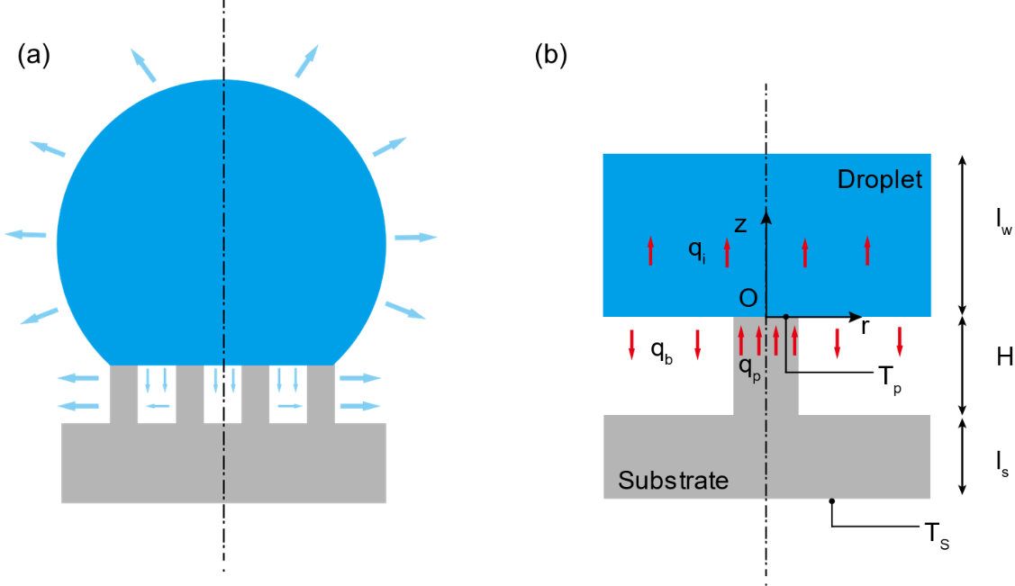

Figure 4. (a) Diagram of evaporation from droplet cap surface and base surface. (b) Diagram of heat transfer from micropillar into droplet base surface.

Evaporation of droplet happens at the liquid-vapor interface. For Cassie state droplet on microstructure substrate, there are air/vapor cavities between the droplet base and the substrate. Different from droplet evaporation on smooth surface for which all the droplet base contacts with the solid substrate, only part of the droplet base contacts with the solid microstructure substrate for Cassie state droplet evaporation. The existence of liquid-vapor interface at the droplet base surface confirms the happening of evaporation at droplet base surface. In previous studies of Cassie state droplet evaporation on microstructure surfaces at room temperature, the evaporation from droplet base surface is always neglected and only the evaporation from droplet cap surface is taken into account. It is reasonable to neglect the evaporation from droplet base surface considering the small liquid-vapor interface area compared with the droplet cap surface and the resistance for the vapor flow caused by the complex surface structures. However, for Cassie state droplet evaporation on hot microstructure substrate, the higher temperature of the droplet base surface compared with the droplet cap surface makes the evaporation from the droplet base surface unneglectable. Both the evaporation from the droplet cap surface and base surface should be taken into account as shown in Fig. 4 (a).

Because of the periodicity of the micropillar arrays, the heat transfer process in one-unit micropillar cell can represent the characteristic of the heat transfer process between the droplet base and substrate micropillars. Thus, we focus on one unit cell of the micropillar and the heat transfer from one-unit micropillar cell into the droplet base surface is shown in Fig. 4 (b). A micropillar cell consists of one micropillar and one air/vapor cavity around the micropillar. In general, heat transfer from both the silicon substrate and the vapor cavity should be calculated. The thermal resistance of the vapor is much larger than the thermal resistance of the silicon micropillar due to the significant ratio between the thermal conductivity of silicon pillars (100 Wm­-1K-1) [] and water vapor (0.025 Wm­-1K-1) []. Therefore, it is reasonable to reasonable to assume the heat primarily conducts from the pillar to the water droplet whereas the vapor-solid interface of cavities boundary can be regarded as adiabatic.

As is mentioned before, heat transferred from the substrate is equal to that released to the ambient air. Thus, we can calculate the substrate heat flux by obtaining the evaporation flux of the water droplet based on the decreasing droplet volume (Eq. 5). We assume the heat flux is uniform from the substrate because of the small area of the micropillar top surface. Thus, heat flux across one unit cell could be calculated as:

$q_{p}=\frac{q_{s}}{N}$ (7)

where N is the number of the micropillar underneath the droplet.

The thermal resistance of the silicon substrate per unit cell could be calculated as:

$R_{s}=\frac{l_{s}}{k_{Si}P^{2}}+\frac{4H}{k_{Si}{πD}^{2}}$ (8)

where $k_{Si}$ is the thermal conductivity of silicon and ls is the thickness of the silicon substrate excluding the height of pillars.

Based on the energy balance inside the silicon substrate, the temperature on the top surface of the micropillar could be calculated as:

$T_{p}=T_{s}-\frac{q_{p}}{R_{s}}$ (9)

Considering the heat flux at the liquid-solid interface, the contact temperature at the liquid vapor interface is calculated as:

$T_{c}=\frac{\sqrt{ρ_{w}k_{w}c_{w}}T_{w}+\sqrt{ρ_{Si}k_{Si}c_{Si}}T_{p}}{\sqrt{ρ_{w}k_{w}c_{w}}+\sqrt{ρ_{Si}k_{Si}c_{Si}}}$ (10)

where $ρ$, c and k are the density, specific heat and thermal conductivity of water and silicon, respectively.

To study the temperature distribution near the liquid-solid interface, i.e., the top surface of micropillar inside the water droplet, a thin water layer with a thickness of lw in a unit cell (Fig. 4) would be considered. The conductive heat transfer equation in this water layer is:

$\frac{∂^{2}T_{ }}{{∂r}^{2}}+\frac{1}{r}\frac{∂T_{ }}{∂r}+\frac{∂^{2}T_{ }}{{∂z}^{2}}=0$ (11)

Due to the small size of the micropillar, the heat flux across the liquid-solid interface and liquid-vapor interface in a unit cell could be assumed as uniform. As a result, we have the first boundary condition:

$k_{w}\frac{∂T_{ }}{∂z}=\left\{\begin{aligned}\frac{q_{p}}{πa^{2}} 0<r<a; z=0 \\ -\frac{q_{b}}{π(b^{2}-a^{2})} a<r<b; z=0\end{aligned}\right.$ (12)

where $k_{w}$ is the thermal conductivity of water, a is the radius of the micropillar and b is the radius of the water cylinder in one unit cell.

Temperature inside the water layer will soon become uniform. Hence, a uniform temperature boundary could be assumed at $z=l_{w}$:

$T_{ }\left(r;z\right)=T_{w} 0<r<b; z=l_{w}$ (13)

Moreover, considering the periodicity of the unit cell, we can assume it is adiabatic between unit cell with its neighbor cell in water layer. Thus, we obtain the adiabatic boundary condition:

$\frac{∂T_{ }}{∂r}=0 r=b; 0<z<l_{w}$ (14)

Solving the heat transfer equation Eq. (11) with the three boundary conditions Eq. (12), Eq. (13), Eq. (14), we can obtain the temperature distribution inside the water layer as:

$T_{b}(r,z)=T_{w}+\frac{q_{p}\left(l_{w}-z\right)}{πk_{w}}\left(\frac{\left(1-φ\right)}{b^{2}}\right)+\frac{2aq_{p}}{πk_{w}}\left(\frac{1}{a^{2}}+\frac{φ}{b^{2}-a^{2}}\right)\sum_{n=1}^{∞}{\left[J_{1}\left(\frac{a}{b}α_{n}\right)J_{0}\left(\frac{r}{b}α_{n}\right){/\left(α_{n}^{2}J_{0}^{2}\left(α_{n}\right)\right)}\right]}\frac{\sinh\left(\left.\frac{α_{n}}{b}{\left(l\right.}_{w}-z\right)\right)}{\cosh\left(\frac{α_{n}}{b}l_{w}\right)}$ (15)

where $φ$ is the evaporation ratio, which is defined as the heat transfer across droplet base over overall heat transfer from substrate to droplet:. J0(x) and J1(x) are the first kind Bessel functions with order of 0 and 1, respectively, $α_{n}$ is the n-th root of J1(x)=0.

The temperature at the droplet base at z=0 is calculated as:

$T_{b}(r,0)=T_{w}+\frac{q_{p}l_{w}}{πk_{w}}\left(\frac{\left(1-φ\right)}{b^{2}}\right)+\frac{2aq_{p}}{πk_{w}}\left(\frac{1}{a^{2}}+\frac{φ}{b^{2}-a^{2}}\right)\sum_{n=1}^{∞}{\left[J_{1}\left(\frac{a}{b}α_{n}\right)J_{0}\left(\frac{r}{b}α_{n}\right){/\left(α_{n}^{2}J_{0}^{2}\left(α_{n}\right)\right)}\right]}\tanh\left(\frac{α_{n}}{b}l_{w}\right)$ (16)

Thus, the average temperature of the droplet base could be obtained as:

${\overline{T}}_{b}=\frac{\int_{0}^{b}{2πr}T_{b}\left(r\right)dr}{πb^{2}}$ (17a)

${\overline{T}}_{b}=T_{w}+\frac{q_{p}l_{w}}{πk_{w}}\left(\frac{\left(1-φ\right)}{b^{2}}\right)$ (17b)

The average temperature of the solid-liquid interface at droplet base could be estimated as:

$T_{b,p}=\frac{\int_{0}^{a}{2πr}T_{b}\left(r\right)dr}{πa^{2}}$ (18a)

$T_{b,p}={\overline{T}}_{b}+\left\{\frac{2aq_{p}}{πk_{w}}\left(\frac{1}{a^{2}}+\frac{φ}{b^{2}-a^{2}}\right)\sum_{n=1}^{∞}{\left[J_{1}^{2}\left(\frac{a}{b}α_{n}\right){/\left(α_{n}^{3}J_{0}^{2}\left(α_{n}\right)\right)}\right]}\tanh\left(\frac{α_{n}}{b}l_{w}\right)\right\}$ (18b)

The temperature at the solid-liquid interface should be the contact temperature, we should have:

$T_{b,p}=T_{c}$ (19)

Thus, the base average temperature of the water droplet could be obtained as:

${\overline{T}}_{b}=T_{c}-\frac{q_{p}2a\left(1+k\right)}{k_{w}}\sum_{n=1}^{∞}{\left[J_{1}^{2}\left(\frac{a}{b}α_{n}\right){/\left(α_{n}^{3}J_{0}^{2}\left(α_{n}\right)\right)}\right]}$ (20)

3.4 Thermal resistance of the water droplet

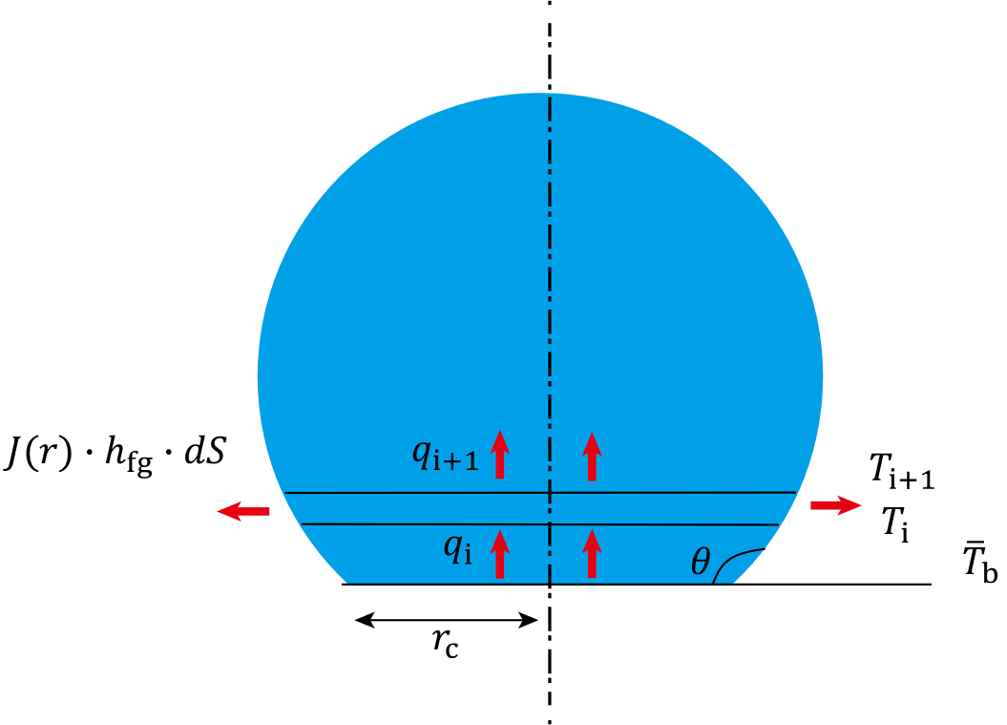

Figure 5. Diagram of heat transfer insider the water droplet

The one-dimensional conduction heat transfer process inside water droplet is shown in Fig. 5. The water droplet is discretized into water layers parallel to the substrate. Heat transfers into the water layer control volume from the bottom surface ($q_{i}$) and transfers out of the control volume from the top surface ($q_{i+1}$) and side surface (${J(r)∙h}_{fg}∙dS$). Temperature is assumed to be uniform at the bottom and top surface of each water layer control volume donated as $T_{i}$ and $T_{i+1}$ respectively. The heat transfer equation in each water layer control volume is listed as:

$T_{i+1}=T_{i}-q_{i}∙R_{i}$ (21)

where $R_{i}$ is the thermal resistance of each water layer control volume calculated as:

$R_{i}=\frac{∆h}{k_{w}πr^{2}}$ (22)

where $∆h$ is the thickness of the water layer and r is the local radius of the water layer.

The energy balance equation in the water layer control volume is

$q_{i+1}=q_{i}-{J(r)∙h}_{fg}∙∆S$ (23)

where $∆S$ is the side surface area of the water layer and $J(r)$ is the local evaporation flux.

The local evaporation flux is calculated based on the diffusion-driven model, which is the solution of the Laplace equation based on Fick’s law of the diffusion of the water vapor around the droplet. The exact solution of the local evaporation flux is calculated as:

$J\left(r\right)=\frac{D_{d}\left(c_{s}\left(T_{s}\right)-RHc_{s}\left(T_{a}\right)\right)}{r_{c}}∙\left[\frac{1}{2}\sin\left(θ\right)+\sqrt{2}{\left(cosh\left(β\right)+cos⁡\left(θ\right)\right)}^{3/2}×\int_{0}^{∞}{\frac{cosh⁡\left(θτ\right)}{cosh⁡\left(πτ\right)}tan\left[\left(π-θ\right)τ\right]⁡×P_{-0.5+iτ}\left(cosh\left(β\right)\right)τ∙dτ⁡}\right]$ (24)

where $T_{s}$ is the temperature at the side surface and $T_{a}$ is the temperature of the ambient air.

The evaporation flux from the droplet cap surface is calculated by integrating the local evaporation rate

$q_{e}=\sum{J\left(r\right)}$ (25)

The evaporation flux from the droplet cap should be the same as the heat flux transferred through the water droplet

$q_{e}=(1-φ)q_{s}$ (26)

As is mentioned before, the experimental temperature of tested by the IR camera is understood as the average temperature of the upper half surface. With obtaining the average base temperature of the water droplet, we can calculate the surface temperature distribution based on the heat transfer equations for the discretized water layers. Thus, we calculate the average of the upper half surface temperature of the droplet:

$T_{model}=\frac{\sum{T_{i}}}{2πr_{w}^{2}}$ (25)

3.5 Algorithm for calculating the surface temperature and evaporation ratio

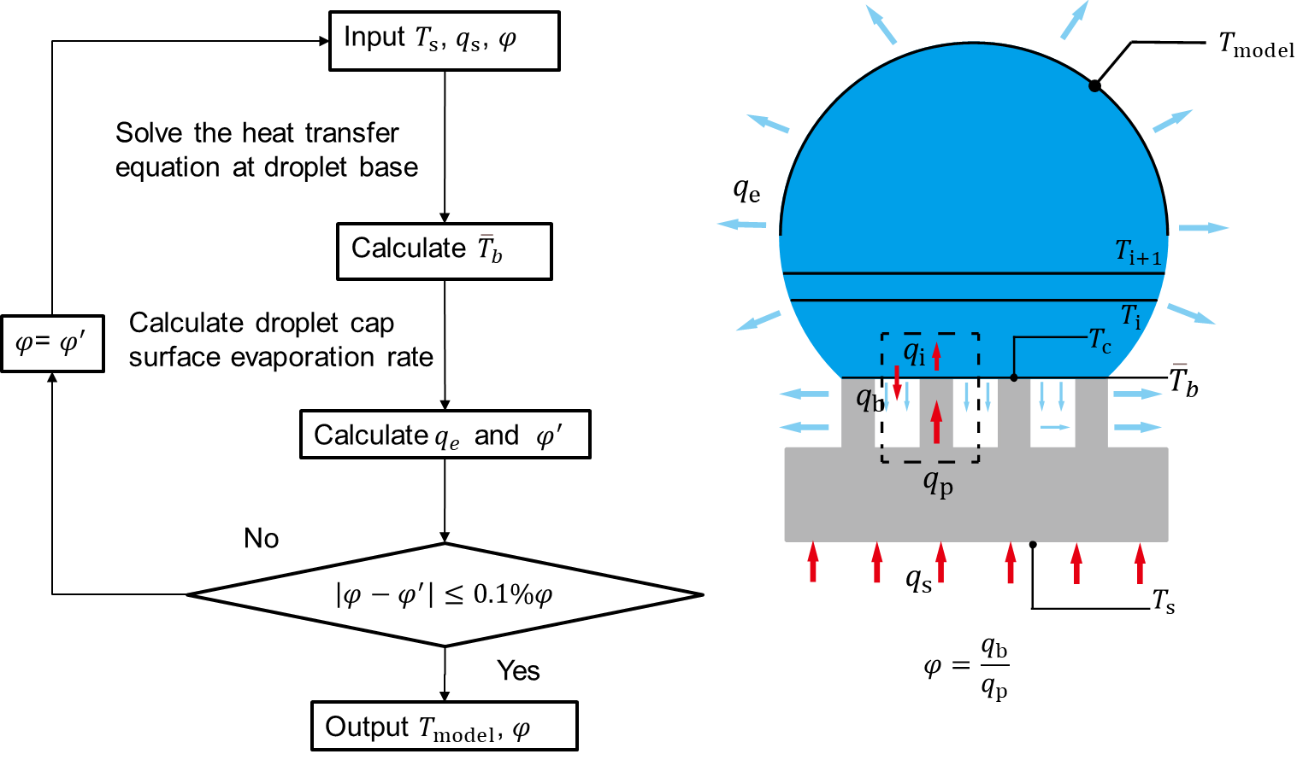

Figure 6. Algorithm for the droplet surface temperature and evaporation ratio

The algorithm for calculating the droplet surface temperature and the evaporation ratio is shown in Fig. 6. The base temperature of the substrate $T_{s}$ is tested by the thermocouple and the heat transfer rate from substrate $q_{s}$ is obtained by calculating the transient droplet volume decrease rate based on Eq. (5). An initial value (0.5) of the evaporation ratio $φ$ which is defined as the ratio of evaporation rate from the droplet base surface and heat transfer rate in the micropillar in one unit cell is used to solve the heat transfer equation at the droplet base. Then, the heat transfer equation Eq. (11) can be solved with knowing all the three boundary conditions. Thus, the temperature distribution at the droplet base surface Eq. (16) is obtained and the average temperature of the droplet base ${\overline{T}}_{b}$ is calculated. Based on the diffusion-driven evaporation mode and the one-dimensional conduction heat transfer model inside the water droplet, the nonuniform surface temperature distribution can be solved. It is not practical to directly calculate the evaporation rate from the droplet base in this study. The evaporation rate from the droplet base surface is calculate as the difference of the total evaporation rate and the evaporation rate from the droplet cap surface based on the energy balance model. The accuracy of the evaporation rate from the droplet base surface dependents on the accuracy of the calculating of evaporation rate from the droplet cap surface. It was calculated by Gleason et al [] that the evaporation rate errors for droplet evaporation on 50 °C substrate and 65 °C substrate are 2.40% and 3.69%, respectively, with considering the surface temperature distribution. The small errors confirm that it is reasonable to predict the droplet cap surface evaporation rate with the surface temperature distribution based on the diffusion-driven model. Thus, the evaporation rate from the droplet cap surface ${ q}_{e}$ is obtained and evaporation ratio $φ$ can be obtained. After the iteration loop achieves convergence, the evaporation ratio and temperature distribution of the droplet cap surface are calculated. With knowing the temperature distribution of the droplet cap surface, the average temperature of the upper half surface of the droplet cap surface $T_{model}$ is calculated and compared with the experimental results for the validation of our thermal circuit model.